use Commercial_Project

-- 1) Show Total Transactions, Total Profit, Profit Margin by Product_Brand

select p.product_brand, COUNT(t.transaction_date) AS number_of_transactions, ROUND(SUM(t.profit),0) AS total_profit,

-- CAST(SUM(profit) / SUM(revenue) AS decimal(10,2)) * 100 AS profit_margin

CAST(SUM(t.profit) / SUM(t.quantity * p.product_retail_price) AS decimal(10,2)) * 100 AS profit_margin

from Transaction_Data t

inner join Products p on t.product_id = p.product_id

group by p.product_brand

-- Show the top 30 product brands, then sort descending by Total Transactions

select TOP 30

p.product_brand, COUNT(t.transaction_date) AS number_of_transactions, ROUND(SUM(t.profit),0) AS total_profit,

-- CAST(SUM(profit) / SUM(revenue) AS decimal(10,2)) * 100 AS profit_margin

CAST(SUM(t.profit) / SUM(t.quantity * p.product_retail_price) AS decimal(10,2)) * 100 AS profit_margin

from Transaction_Data t

inner join Products p on t.product_id = p.product_id

group by p.product_brand

order by COUNT(t.transaction_date) DESC

-- Show total transactions by start of month

select DATETRUNC(MONTH, c.date) AS start_of_month, COUNT(transaction_date) AS number_of_transactions from Transaction_Data t

inner join calendar c on c.date = t.transaction_date

group by DATETRUNC(MONTH, c.date)

-- Show Total Transactions by store city and country

select COUNT(t.transaction_date) AS number_of_transactions, s.store_country, s.store_city from Transaction_Data t

inner join Stores s on s.store_id = t.store_id

group by s.store_country, s.store_city

-- Show Total transactions by store country and store_city

-- Window function OVER() clause

select CONCAT_WS(' ', c.first_name, c.last_name) AS customer_full_name, s.store_country, s.store_city, t.transaction_date,

COUNT(t.transaction_date) OVER() AS overall_number_of_transactions,

COUNT(t.transaction_date) OVER(PARTITION BY s.store_country, s.store_city) AS store_country_city_number_of_transactions

from Transaction_Data t

inner join Stores s on s.store_id = t.store_id

left join Customers c on c.customer_id = t.customer_id

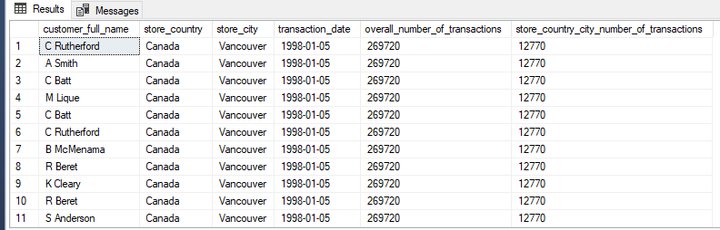

-- Pull the weekly revenue trending. Only show data for 1998

select DATETRUNC(WEEK, c.Date) AS start_of_week, ROUND(SUM(t.quantity * p.product_retail_price),0) AS total_revenue

from Transaction_Data t

left join Calendar c on t.transaction_date = c.Date

left join Products p on p.product_id = t.product_id

where DATEPART(YEAR, c.Date) = 1998

group by DATETRUNC(WEEK, c.Date)

order by DATETRUNC(WEEK, c.Date) ASC

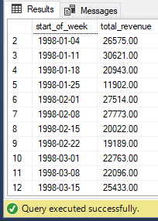

-- Pull the Top Customer in terms of Total Revenue and Total Orders – Optional Question

